

**AMERICAN INTERNATIONAL UNIVERSITY–BANGLADESH (AIUB)**

**FACULTY OF SCIENCE AND TECHNOLOGY**

**COURSE NAME: COMPILER DESIGN**

**Spring 2023-2024**

**FINAL LAB ASSIGNMENT**

**Supervised By**

# NAZMUS SAKIB SHAN

**Submitted By**

|  |  |
| --- | --- |
| **Name** | **ID** |
| **MD ZAHIDUL ISLAM** | **22-46022-1** |

Date of Submission: **04** **May, 2024**

**GitHub Link**

**Error-1:** Datatype name

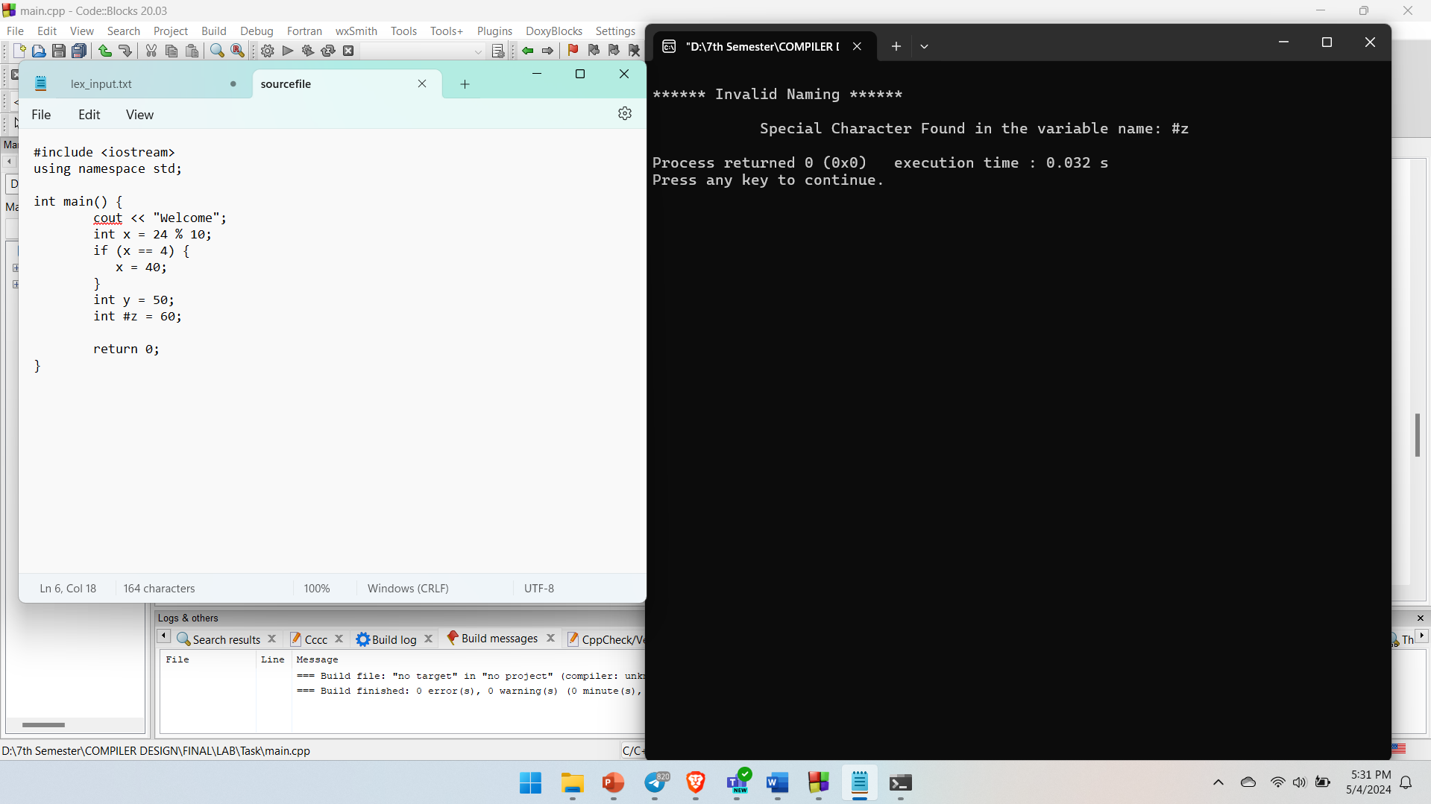

**Error-2:** Invalid Variable name declaration

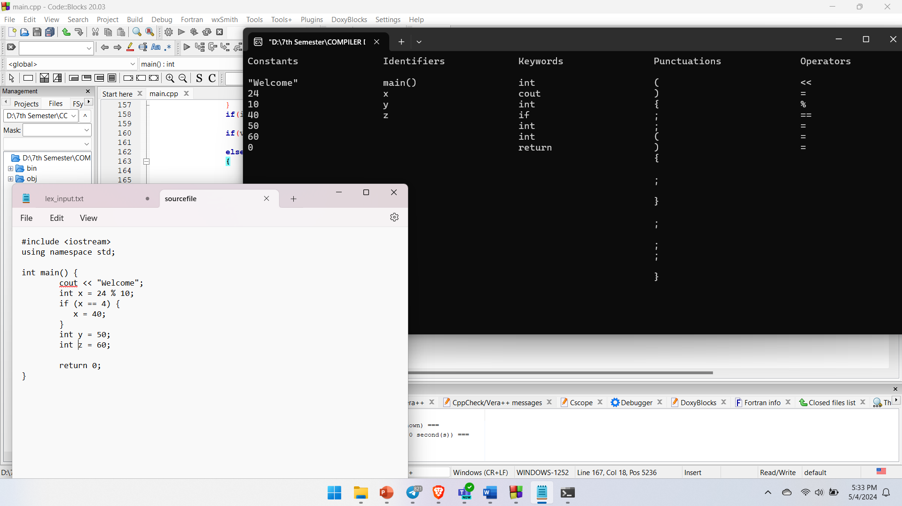

**Output:** Tokens Generated

**Output:** Tokens Generated